
THE REVOLUTIONARY GOVERNMENT OF ZANZIBAR
MINISTRY OF FINANCE AND PLANNING (MOFP)
BOOSTING INCLUSIVE GROWTH FOR ZANZIBAR (BIG-Z)

SURVEY REPORT ON THE ASSESSMENT OF UTILIZATION, FUNCTIONALITY, MANAGEMENT, AND SUSTAINABILITY OF LABORATORY EQUIPMENT SUPPLIED TO THE ZANZIBAR BUREAU OF STANDARDS (ZBS)

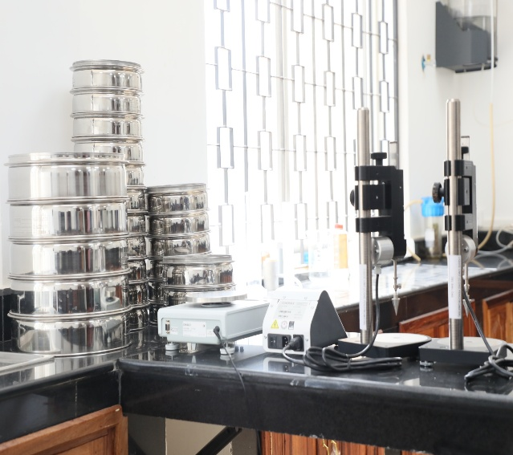 | 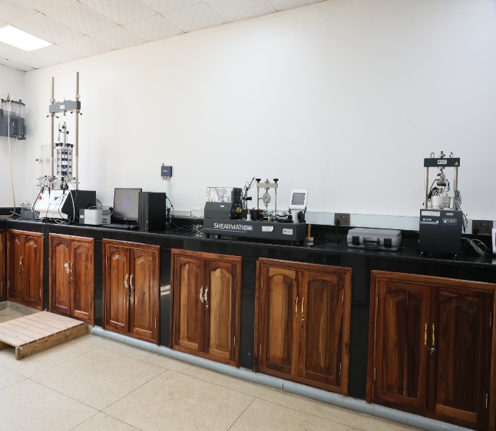

Tanzania, Project ID: P165128
IDA Credit No:69140-TZ

PREPARED BY M&E UNIT | DECEMBER 2025

Introduction
The Ministry of Finance and Planning (MoFP) is implementing the Boosting Inclusive Growth for Zanzibar (BIG-Z) Integrated Development Project, a flagship initiative financed by the World Bank with a total allocation of USD 150 million. The project commenced in 2021 and is scheduled for completion in December 2027. It aims to promote inclusive and sustainable economic growth across Zanzibar through coordinated, multi-sectoral development interventions. The BIG-Z Project focuses on improving urban infrastructure, strengthening institutional capacity, enhancing service delivery, and expanding economic opportunities for communities across Unguja and Pemba.
In line with its objective of modernizing and improving service delivery at the Zanzibar Bureau of Standards (ZBS), the BIG-Z Project financed the procurement of laboratory equipment to strengthen ZBS’s capacity to assess the quality and conformity of goods entering Zanzibar. The procured equipment includes a Hydraulic Type Universal Testing Machine, Automatic Compression Cement Tester, Le Chatelier Mould, Le Chatelier Water Bath, and a Circulating Water Bath with Cooler Unit. This investment is intended to enhance the operational efficiency of ZBS, reduce reliance on the Tanzania Bureau of Standards, and strengthen the institutional sustainability of ZBS in support of Zanzibar’s broader regulatory and quality assurance framework.
To assess the utilization and performance of the supplied equipment, the Monitoring and Evaluation (M&E) Unit conducted a structured field assessment using the standard BIG-Z Equipment Assessment Questionnaire. The assessment focused on evaluating utilization levels, functionality, operational readiness, maintenance practices, and the overall effectiveness of the equipment deployed at ZBS.
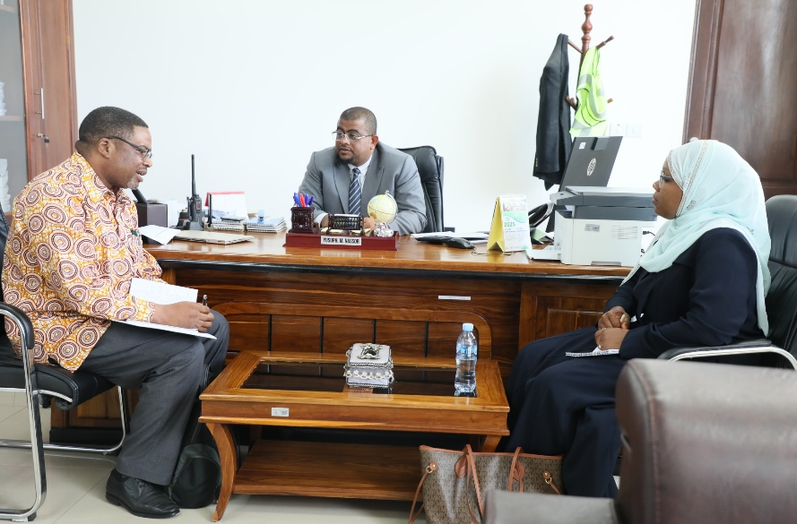 | Photo 1: Mr. Yusuph M. Nassor, Director General of the Zanzibar Bureau of Standards, outlining strategic measures implemented to safeguard laboratory equipment supported by the Big Z Project. During the evaluation conducted by the Big Z Monitoring and Evaluation Unit, he highlighted the decision to ensure that all project-supported equipment is fully insured, with the objective of sustaining government assets while ensuring the continued provision of effective and efficient services.

This report presents the findings of the assessment and provides insights into the operational performance of the equipment, emerging challenges, and sustainability considerations. The assessment sought to determine whether the equipment is effectively supporting ZBS’s core mandates, operating as intended, adequately managed, and likely to be sustained over the medium to long term. The findings are expected to inform evidence-based decision-making, guide future capacity-building initiatives, and strengthen asset management and sustainability planning within the institution.

Objectives of the Assessment
The specific objectives of the survey were to comprehensively assess the performance and sustainability of laboratory equipment supplied to the Zanzibar Bureau of Standards (ZBS). In particular, the survey aimed to:
- Assess the level and frequency of utilization of the supplied laboratory equipment in order to determine the extent to which the assets are being actively used to support ZBS core operational and regulatory functions.
- Evaluate the operational status and functionality of the equipment, including its technical performance, reliability, and suitability for intended testing and quality assurance activities.
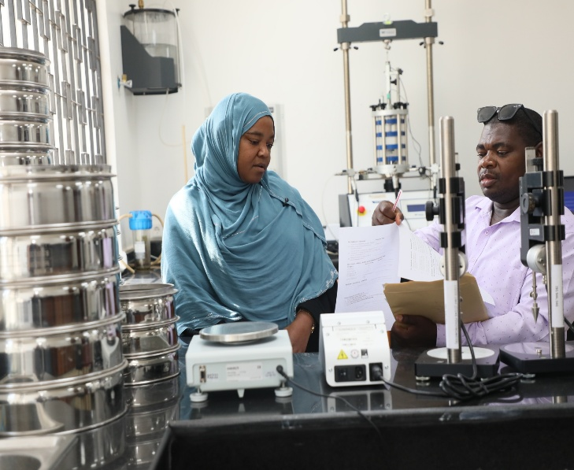 | 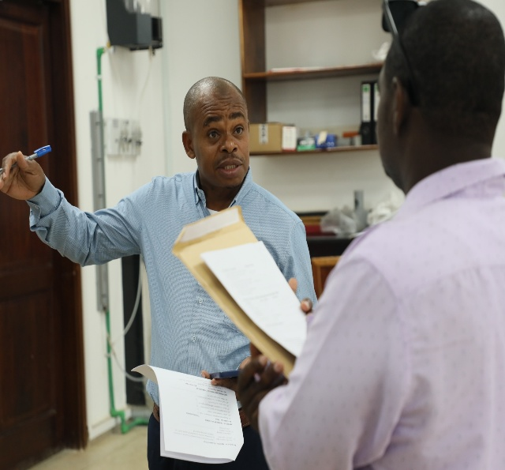
Photo 2: Mr. Hamid A. Haji, Monitoring and Evaluation Officer for the Big Z Project, and Eng. Halima A. Abbas of the Zanzibar Bureau of Standards jointly reviewing project-supported laboratory equipment, with a focus on assessing its utilization, performance, and long-term sustainability | Photo 3: Eng. Ali Hamad Ali, Director of the Laboratory Department at the Zanzibar Bureau of Standards, explaining the operationalization of the laboratory department and the effectiveness of the project-supported equipment to Mr. Hamid A. Haji, Monitoring and Evaluation Officer, during the equipment evaluation exercise.
- Review the effectiveness of management arrangements, with particular emphasis on maintenance systems, availability and use of operational documentation, asset tracking mechanisms, and the adequacy of staffing and assigned responsibilities for equipment operation and oversight.
- Identify sustainability risks, institutional capacity gaps, and areas requiring strengthening, including challenges related to skills, maintenance financing, availability of spare parts, and institutional support mechanisms.
- Provide evidence-based recommendations to enhance the effective utilization, management, and long-term sustainability of the equipment, and to inform future capacity-building, investment, and asset management decisions under the BIG-Z Project.
3. Methodology
The assessment was conducted using a structured survey instrument administered to responsible technical staff at the Zanzibar Bureau of Standards (ZBS). The survey targeted equipment users, laboratory technicians, and designated custodians with direct responsibility for the operation, maintenance, and oversight of the supplied laboratory equipment at the Maruhubi laboratory facility.
Data were collected through face-to-face engagements and direct responses to the standardized questionnaire, enabling the capture of both quantitative ratings and qualitative observations related to equipment performance. The survey was designed to assess multiple dimensions of equipment management and use, including levels of utilization, operational functionality, calibration and maintenance practices, availability of technical documentation, staff capacity and training, and the adequacy of institutional support and management systems.
This approach ensured a comprehensive and systematic assessment of the operational status and sustainability of the equipment, while also allowing for the identification of practical challenges, capacity gaps, and opportunities for improvement to inform evidence-based decision-making and future interventions.

The assessment was conducted using a structured survey tool administered to responsible technical staff at ZBS. Data were collected through direct responses from equipment users and custodians at the Maruhubi laboratory facility. The survey covered multiple dimensions, including utilization, functionality, maintenance practices, staff capacity, and institutional support systems.

Scope of the Assessment
The assessment covered laboratory equipment supplied to ZBS, focusing on key instruments critical to material testing and quality assurance. The equipment assessed included the following:
• Hydraulic Type Universal Testing Machine, used for comprehensive strength and performance testing of construction materials.
• Automatic Compression Cement Tester, supporting accurate and efficient evaluation of cement compressive strength.
• Le Chatelier Mould, utilized for determining the soundness of cement.
• Le Chatelier Water Bath, facilitating controlled testing conditions for cement expansion analysis.
• Circulating Water Bath with Cooler Unit, ensuring precise temperature regulation required for reliable laboratory testing.
These instruments form an integral part of ZBS’s laboratory infrastructure and play a vital role in supporting its operational and regulatory testing functions.
THE NAMES AND PHOTOS OF ZBS LABORATORY EQUIPMENT SUPPLIED
SN | EQUIPMENT | SN | EQUIPMENT
COCRETE AND SOIL LAB
1 | 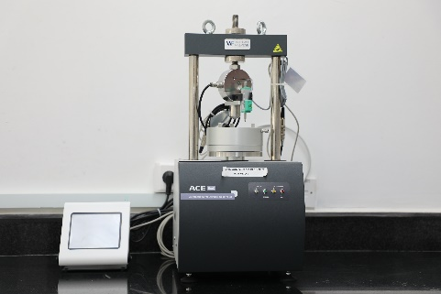 | 2 | 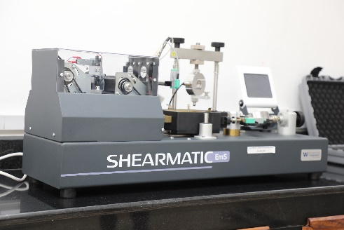
 | AUTOMATIC COMPUTERIZED OEDOMETER |  | AUTOMATIC SHEAR TESTING MACHINE
3 | 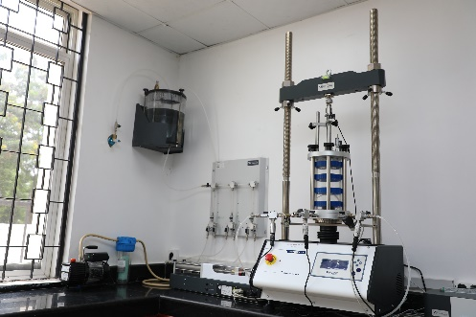 | 4 | 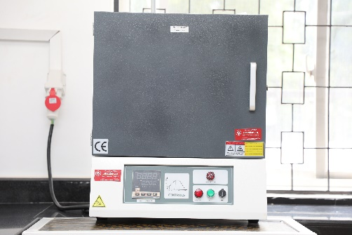
 | AUTOMATIC TRIAXIAL TESTS SYSTEM |  | MUFFLE FURNACE
5 | 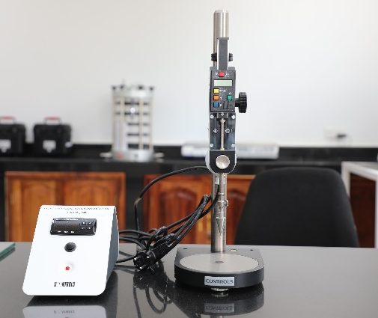 | 6 | 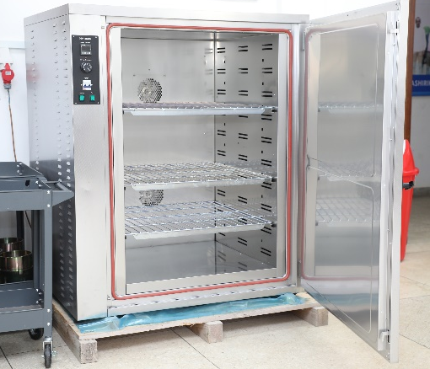
 | LIQUID LIMIT (CONE PENETROMETER DEVICE) |  | LABORATORY OVEN
7 | 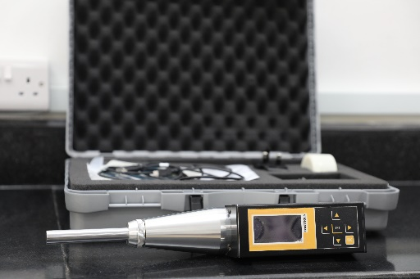
 | DIGITAL REBOUND HAMMER TEST
BITUMEN LAB
1 | 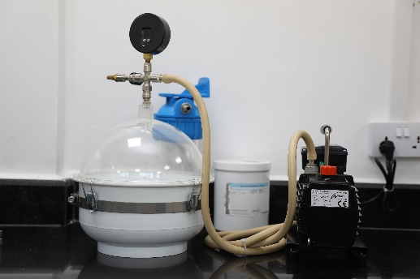 | 2 | 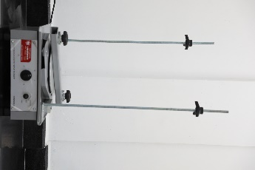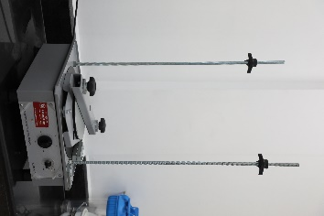
 | VACUUM DESSICATOR PYKNOMETER APPARATUS |  | ELECTROMAGNETIC SIEVE SHAKER
3 | 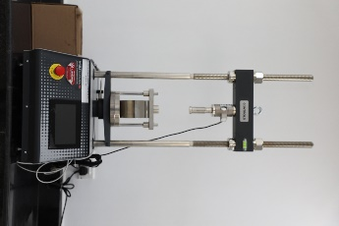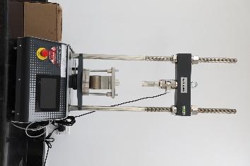 |  | 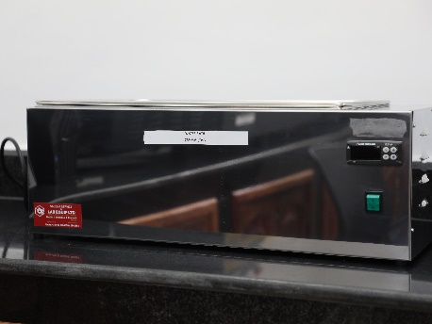
 | DIGITAL AUTOMATIC UNIVERSAL TESTER FOR CBR AND MARSHALL TEST |  | WATER BATH
5 | 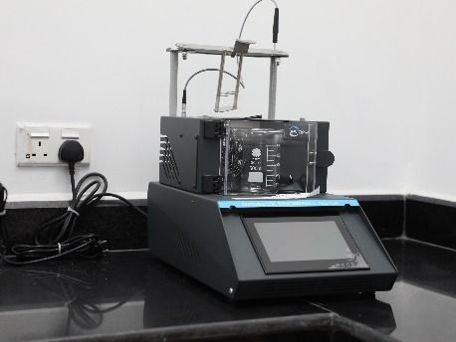 | 6 | 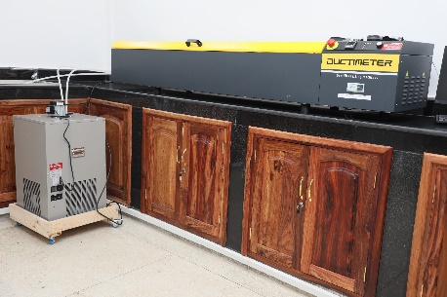
 | AUTOMATIC DIGITAL RING AND BALL APPARATUS |  | DUCTIMETER WITH DATA ACQUISITION SYSTEM
7 | 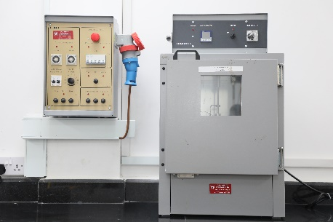 | 8 | 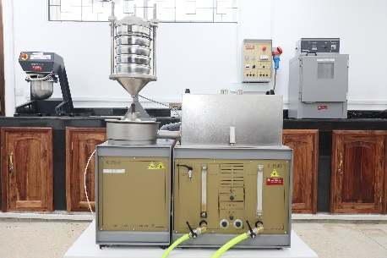
 | TFOT BITUMEN OVEN |  | AUTOMATIC BITUMEN EXTRACTOR
9 | 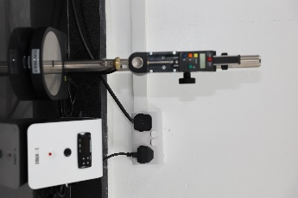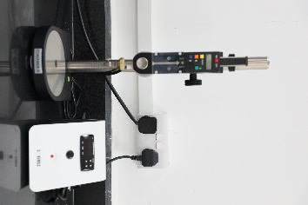 | 10 | 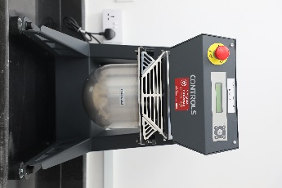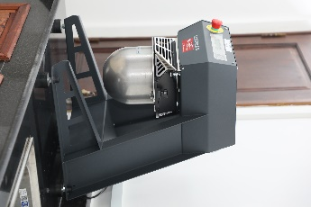
 | STANDARD DIGITAL PENETROMETER |  | AUTOMATIC ASPHALT MIXER
11 | 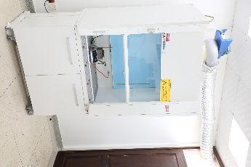 | 12 | 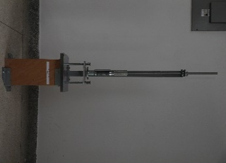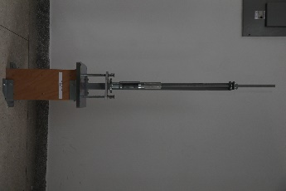
 | EXHAUST FUME HOOD |  | MARSHALL COMPACTOR
13 | 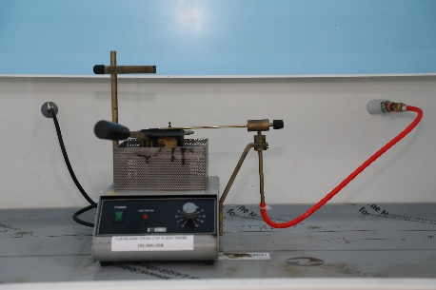
 | CLEVELAND OPEN CUP FLASH TESTER
CEMENT LAB
1 | 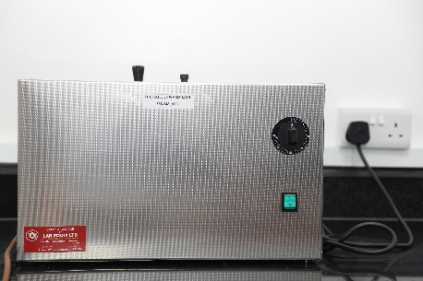 | 2 | 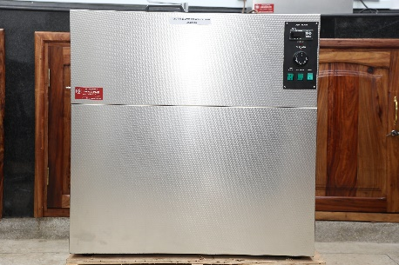
 | LE CHATELIER WATER BATH |  | CIRCULATING WATER BATH WITH COOLER UNIT
3 | 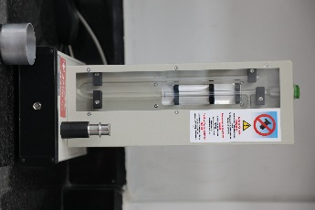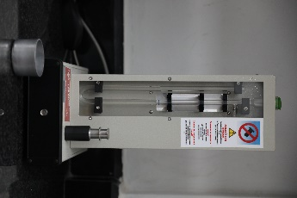 | 4 | 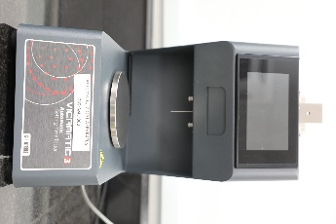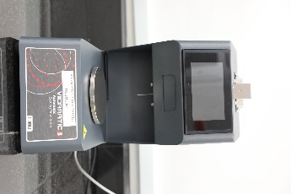
 | AUTOMATIC BLAINE AIR PERMEABILITY APPARATUS |  | AUTOMATIC VICAT APPARATUS
5 | 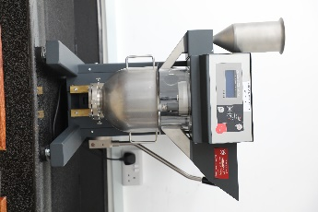 | 6 | 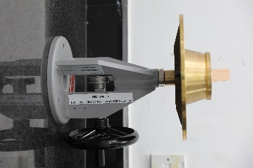
 | AUTOMATIC MORTAR MIXER |  | FLOW TABLES
7 | 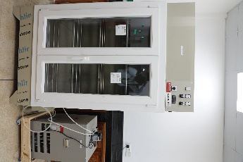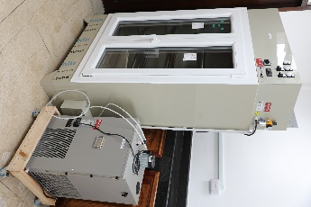
 | HUMIDITY CABINET/CHAMBER
MECHANIC LAB
1 | 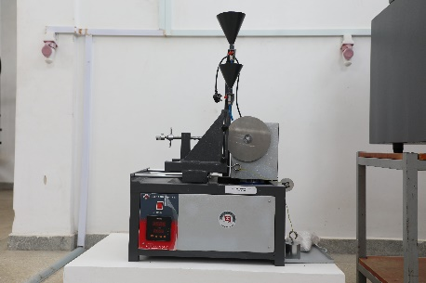 | 2 | 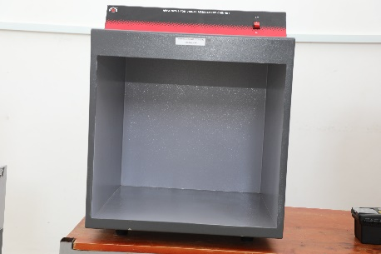
 | DEEP ABRASION TILE MACHINE |  | VIEWING CABINET (P.E.I BOX)
3 | 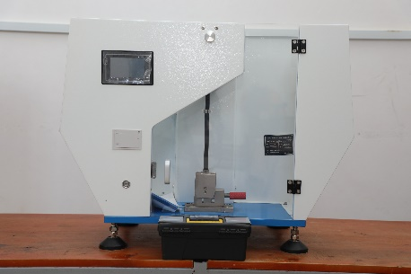 |  | 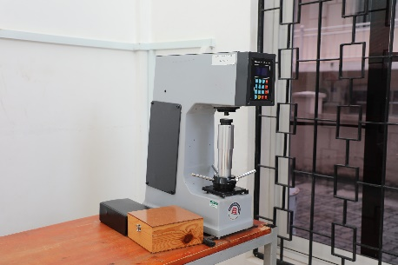
 | IMPACT TESTING MACHINE |  | ROCKWELL HARDNESS TESTER
5 | 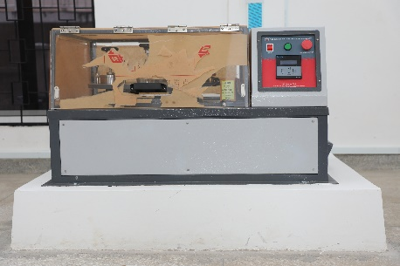 | 6 | 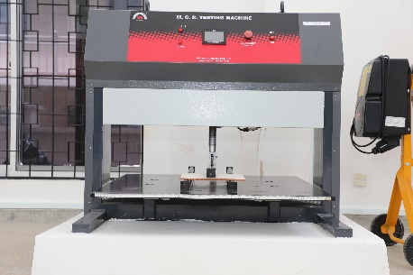
 | SURFACE ABRASION TILE MACHINE |  | CERAMIC TILE BREAKING STRENGTH MACHINE
7 | 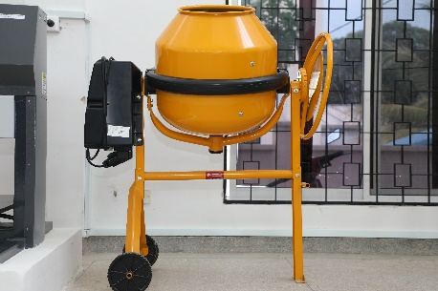 | 8 | 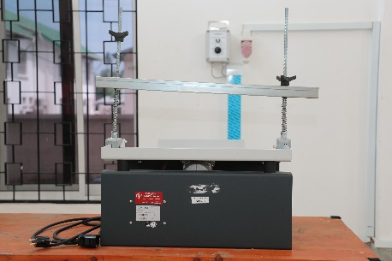
 | CONCRETE MIXER |  | VIBRATING TABLE
9 | 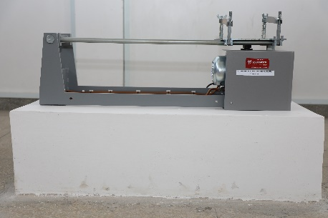 | 10 | 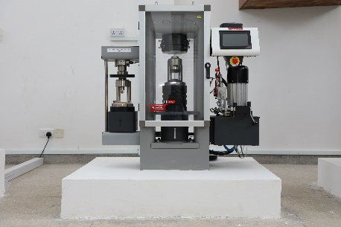
 | JOLTING APPARATUS |  | AUTOMATIC COMPRESSION-FLEXURAL CEMENT TESTER
11 | 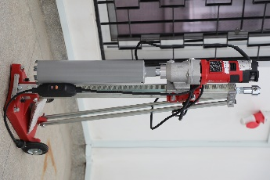 |  | 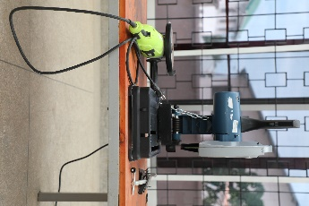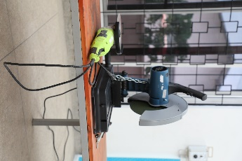
 | CORE DRILLING MACHINE |  | ABRASIVE DISC CUTTING MACHINE
13 | 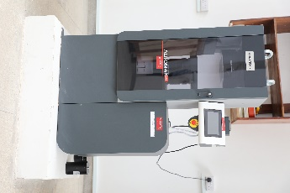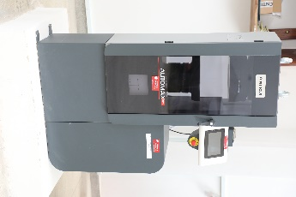 | 14 | 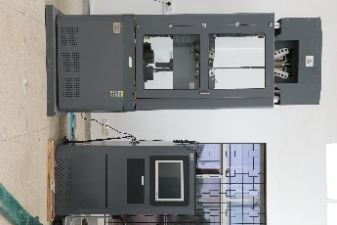
 | AUTOMATIC COMPRESSION TESTER FOR CONCRETE CUBES AND CYLINDERS |  | UNIVERSAL TESTING MACHINE
15 |  | 16 | 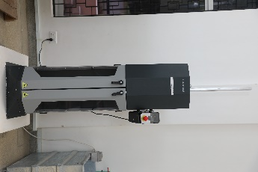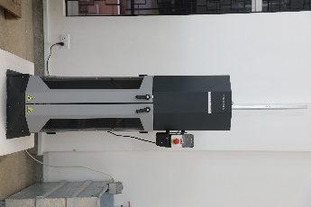
 | UNIVERSAL TESTING MACHINE |  | UNIVERSAL PROCTOR/CBR AUTOMATIC COMPACTOR
17 | 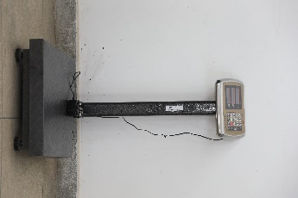
 | ELECTRONIC BALANCE

5. Key Findings

5.1 Equipment Utilisation
All laboratory equipment assessed under this survey is currently in active use and is effectively supporting the core laboratory testing, inspection, and regulatory functions of the Zanzibar Bureau of Standards (ZBS). The equipment is routinely deployed in day-to-day operations, contributing directly to the assessment of product quality and compliance with applicable standards.
Utilization levels were consistently rated as very high across all equipment categories, with an average utilization score of 5 out of 5, indicating optimal and sustained use. Respondents confirmed that the equipment is fully integrated into routine laboratory workflows and is essential to the execution of mandated testing activities.
In addition, respondents reported that the existing working environment—including laboratory space, utilities, safety arrangements, and operational conditions—is conducive to effective equipment use. The facilities were considered to be well aligned with the technical and operational requirements of the equipment, thereby enabling efficient performance and minimizing operational constraints.

5.2 Functionality and Operational Status
All laboratory equipment assessed was reported to be fully functional and operating as intended at the time of the assessment. The equipment was found to be in good operational condition and capable of performing the testing functions for which it was procured.
Functionality ratings were consistently high, with an average score of 5 out of 5 across all assessed equipment, reflecting optimal technical performance and reliability. Respondents confirmed that the equipment meets required performance standards and supports accurate and efficient laboratory testing.
No major equipment breakdowns were reported during the six months preceding the assessment. Where minor operational or maintenance issues were encountered, these were promptly addressed through routine troubleshooting and corrective maintenance, resulting in minimal disruption to laboratory operations.
In addition, commissioning and calibration processes were reported to have been successfully completed in accordance with manufacturer specifications. User manuals, operating guidelines, and relevant technical documentation were generally available and accessible to laboratory staff, supporting proper operation, maintenance, and compliance with quality assurance requirements.

5.3 Management Arrangements
Designated officers have been formally assigned responsibility for the management, operation, and oversight of the laboratory equipment. These officers are accountable for ensuring proper use, routine maintenance, and compliance with established operational and safety requirements.
Standard operating procedures (SOPs), preventive maintenance schedules, and asset registers were reported to be available and actively utilized. These management tools provide a structured framework for equipment operation, monitoring, and lifecycle management, and contribute to consistency, accountability, and effective asset tracking.
Preventive maintenance practices are generally observed and are supported by institutional arrangements, including planned servicing, routine inspections, and internal coordination mechanisms. These practices have contributed to maintaining the equipment in good working condition and minimizing the risk of unplanned downtime.
Overall, the management and sustainability of the assessed equipment were rated very highly, with an average score of 5 out of 5 across all equipment. This reflects strong institutional capacity, effective management systems, and a favorable outlook for the continued operational sustainability of the assets over the medium to long term.

5.4 Human Capacity and Training
Laboratory staff have received initial training on the operation and use of the supplied equipment and are actively engaged in its day-to-day application in support of ZBS testing and regulatory functions. The training provided has enabled staff to operate the equipment effectively and has contributed to the high levels of utilization observed during the assessment.
Notwithstanding these positive outcomes, respondents identified a continued need for additional and refresher training to further strengthen technical capacity and reduce operational and maintenance risks. As equipment usage increases and testing demands evolve, periodic training updates are considered essential to ensure sustained performance, compliance with technical standards, and continuity of operations.
Key capacity gaps were identified in areas related to advanced equipment operation, fault diagnosis and troubleshooting, and routine and corrective maintenance. Addressing these gaps through targeted capacity-building interventions—such as advanced technical training, on-the-job coaching, and supplier-supported maintenance training—would enhance operational resilience and support the long-term sustainability of the equipment.

5.5 Sustainability and Risk Assessment
Annual budget allocations for the maintenance and servicing of laboratory equipment are generally available, indicating institutional recognition of the importance of preserving asset functionality. However, sustained commitment and periodic review of budget adequacy will be required to ensure that maintenance needs continue to be met as the equipment ages and operational demands increase.
Access to spare parts and consumables was reported to be largely adequate, enabling timely replacement and continued operation of the equipment. Nevertheless, reliance on external suppliers—particularly for specialized components—presents a potential sustainability risk, especially in the event of supply chain disruptions or delays.
The assessment further revealed that partnerships aimed at supporting long-term equipment sustainability are limited. Most respondents indicated the absence of formal collaboration arrangements with equipment suppliers, service providers, or training institutions that could provide ongoing technical support, maintenance services, or capacity-building opportunities.
Overall, the risk level associated with the assessed equipment was rated as low, reflecting strong utilization rates, high functionality, effective management arrangements, and generally adequate institutional support. While the current outlook is positive, proactive measures—particularly in strengthening partnerships and long-term maintenance planning—will be important to sustain performance over the medium to long term.

6.6 Advanced technology and Cost-effectiveness
The laboratory equipment procured under the project is advanced and aligned with modern testing and analytical standards, significantly enhancing ZBS's in-house technical capacity. As a result, ZBS is now able to conduct a wide range of specialized analyses internally, which has substantially reduced the need to send staff to external institutions such as the University of Dar es Salaam and the Tanzania Bureau of Standards on the Tanzania Mainland. This has led to notable cost savings related to travel, accommodation, and external laboratory fees, while also improving turnaround times, operational efficiency, and staff productivity. Overall, the acquisition of advanced equipment has strengthened institutional self-reliance and delivered measurable efficiency gains.
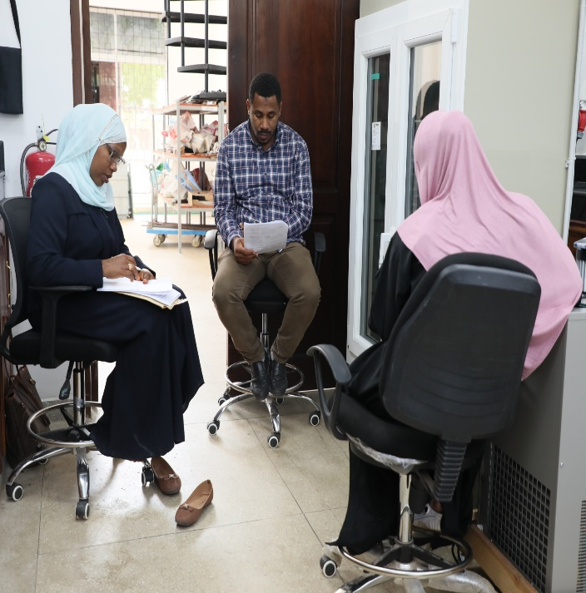 | 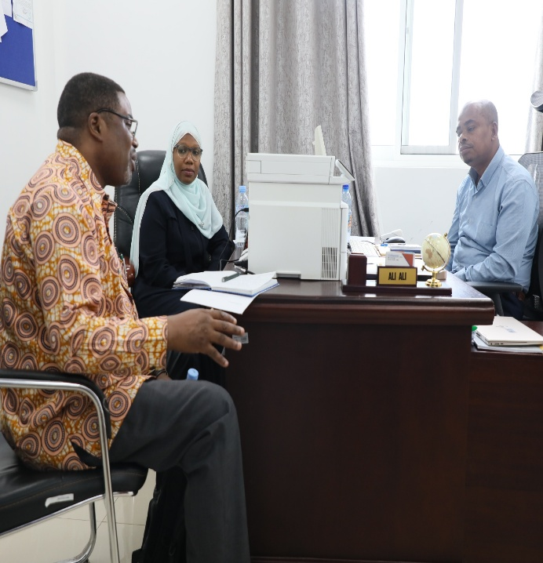
Photo 4: Ms. Mwanajuma Ameir, Monitoring and Evaluation Officer for the Big Z Project, conducting an assessment of the project-supported laboratory equipment together with Eng. Salim Kassim Juma and Eng. Amira Salum Taufiq, focusing on equipment functionality, utilization, and compliance with operational standards. | Photo 5: Eng. Ali Hamad Ali, Director of the Laboratory Department at the Zanzibar Bureau of Standards, addressing the evaluation team on how the project-supported equipment has strengthened institutional service delivery across Zanzibar Island. Also pictured are Mr. Israel Mwakilasa and Ms Mwanajuma Ameir from the Big Z Project M&E unit.

6. Challenges Identified
While overall performance remains strong, several key challenges have been identified that warrant attention:
• Continuous and Advanced Staff Training: Ongoing capacity building is essential to ensure that staff remain equipped with the latest technical skills and knowledge. Regular training programs, including advanced and specialized courses, will strengthen operational efficiency and adaptability.
• Limited Formal Partnerships for Long-Term Sustainability: Current collaboration with external partners is minimal. Establishing formal partnerships with relevant organizations, suppliers, and technical institutions will enhance resource sharing, knowledge exchange, and long-term sustainability of operations.
• Potential Risks Related to Maintenance Funding and Backup Equipment: Although current maintenance practices are effective, the availability of sufficient funding and backup equipment remains a potential vulnerability. Proactive planning, including budget allocation for contingencies and development of equipment redundancy strategies, is recommended to mitigate these risks.

7. Conclusions
The survey findings indicate that the laboratory equipment supplied to ZBS is being effectively utilized, remains fully functional, and is supported by well-established management systems. This equipment is making a substantial contribution to ZBS’s operational efficiency and regulatory functions, enhancing the organization’s capacity to fulfill its mandate.
Sustainability risks associated with the equipment are currently assessed as low. Nevertheless, proactive measures are essential to maintain this favorable status. These measures include regular maintenance, timely availability of spare parts, continuous staff training on proper equipment handling, and strategic planning to address potential operational or financial challenges.
Additionally, it was noted that the equipment is fully insured, providing protection against potential damages or unforeseen events. This insurance coverage further strengthens the sustainability of the laboratory infrastructure, ensuring that ZBS can continue to rely on the equipment for its operational and regulatory activities over the long term.
8.0 Recommendations
To further enhance the effective use and long-term sustainability of laboratory equipment at ZBS, the following actions are recommended:
- Institutionalize Regular Refresher and Advanced Training Programs:
Establish ongoing training programs for laboratory staff, including refresher courses and advanced skill development. This will ensure personnel remain proficient in operating complex equipment, adopt best practices, and adapt to evolving technologies.
- Ensure Consistent and Adequate Budget Allocations for Maintenance:
Allocate sufficient resources for preventive maintenance, timely repairs, and the procurement of spare parts. A well-planned and consistently funded maintenance schedule will minimize equipment downtime and extend operational life.
- Strengthen Documentation and Continuous Updating of SOPs and Asset Registers:
Maintain comprehensive and up-to-date standard operating procedures (SOPs), equipment manuals, and asset registers. Accurate documentation supports accountability, facilitates training, and ensures that operational procedures are consistently followed.
- Explore and Formalize Strategic Partnerships:
Develop formal partnerships with equipment suppliers, service providers, and training institutions. Such collaborations can provide technical support, capacity building, and access to specialized services, contributing to the long-term sustainability of laboratory operations.
- Consider Acquisition of Backup Equipment:
Where feasible, procure backup or redundant equipment to mitigate risks associated with equipment failure or maintenance downtime. This will ensure uninterrupted laboratory operations and strengthen ZBS’s resilience in critical regulatory functio
9. Lessons Learned from the Laboratory Equipment Survey at ZBS
- Effective Utilization and Management Are Critical:
Properly managed equipment, supported by clear operational procedures and management systems, maximizes both functionality and impact. Well-maintained equipment contributes directly to operational efficiency and regulatory effectiveness.
- Proactive Measures Sustain Low Risk Levels:
Even when current sustainability risks are low, ongoing proactive measures—such as regular maintenance, staff training, and contingency planning—are essential to maintain reliability and prevent operational disruptions.
- Insurance Enhances Equipment Resilience:
Fully insuring laboratory equipment provides an additional layer of protection against unexpected events, reinforcing the long-term sustainability of critical infrastructure.
- Staff Competency Directly Impacts Equipment Effectiveness:
Continuous training and capacity building ensure that personnel can utilize equipment optimally, reducing the risk of misuse or underperformance.
- Partnerships and Resource Planning Strengthen Sustainability:
While internal management systems are strong, formal partnerships with suppliers, technical institutions, or other stakeholders can further secure long-term operational support, spare parts availability, and technical guidance.
- Monitoring and Assessment Inform Decision-Making:
Periodic surveys and assessments provide valuable insights into equipment performance, risks, and management effectiveness, allowing ZBS to make informed decisions and prioritize interventions where needed

9.0 Effectiveness, Efficiency, and Successes of the Big Z Project for ZBS
Effectiveness:
The Big Z Project has significantly strengthened ZBS’s operational and regulatory capabilities. Laboratory equipment supplied through the project is fully functional and effectively utilized, enabling timely and accurate testing and analysis. The project has enhanced staff capacity through targeted training and improved operational workflows, ensuring that ZBS can meet its mandate more effectively. Furthermore, the integration of robust management systems has streamlined laboratory operations, contributing to consistent and reliable outcomes.
Efficiency:
Resources provided by the Big Z Project have been optimally utilized, with minimal wastage and maximum impact. The project’s planning and implementation processes ensured that equipment, training, and support systems were delivered promptly, aligning closely with ZBS’s operational needs. Strong project oversight and monitoring mechanisms have allowed for quick identification and resolution of any operational challenges, thereby maintaining high levels of efficiency in project execution.
Successes:
The project has achieved several notable successes:
- Provision of fully functional and insured laboratory equipment that directly supports ZBS’s operational and regulatory functions.
- Strengthening of institutional management systems and operational procedures, enhancing overall laboratory performance.
- Capacity building of ZBS staff through training programs, improving technical skills and equipment handling.
- Low sustainability risks, reflecting effective planning, management, and proactive measures for long-term equipment reliability.
- Contribution to ZBS’s broader mandate, enabling more accurate testing, improved compliance monitoring, and better service delivery to stakeholders.
Overall, the Big Z Project has delivered tangible improvements in ZBS’s operational efficiency, regulatory effectiveness, and institutional resilience, laying a strong foundation for sustained impact in the future.

The report has been prepared based on survey results from the ZBS Laboratory Equipment Utilisation and Management Assessment.

.

ANNEX 1: EQUIPMENT INVENTORY
EQUIPMENT SUPPLIED TO ZANZIBAR BUREAU STANDARD
LOT 1 CEMENT LAB EQUIPMENT |  | LOT 3 CONCRETE LAB EQUIPMENT
1. | Automatic Compression Cement Tester | 1 | Digital Rebound Hammer Test
2. | Le Chatelier Mould | 2 | Vibrating Table
3 | Le Chatelier Water Bath | 3 | Slump Cone set
4 | Circulating Water Bath with Cooler Unit | 4 | Concrete Cube Moulds
5 | Le Chatelier Flask | 5 | Concrete Cylinder Moulds
6 | Jilting Apparatus For 40*40*160 MM Prisms | 6 | Concrete Mixers
7 | Automatic Vicat Apparatus | 7 | Curing Tank
8 | Flow Tables for Mortar and Building lime | 8 | Automatic Compression testers for Cubes and Cylinder
9 | Humidity Cabinet/Chamber | LOT 5 ASPHALT AND BITUMEN LAB EQUIPMENT
10 | Three Gang Molds | 1 | Digital Automatic Universal Tester for CBR Test and Marshall test
11 | Automatic Mortar Mixers | 2 | Automatic Asphalt Mixers
12 | Muffle Furnace | 3 | Standard and Digital Penetrometer
13 | Automatic Blaine Air Permeability Apparatus | 4 | Automatic Digital Ring and Ball Apparatus
14 | Porcelain Crucible | 5 | Ductilometer with data acquisition System
15 | Electronic Balance | 6 | Tfot Bitumen Oven
16 | Analytical Balance | 7 | Exhaust Fume Hood with Aspirator
17 | Stop Watch | 8 | Automatic Bitumen Extractor
LOT 2 REINFORCEMENT TILES AND METAL SHEETS LAB EQUIPMENT |  | 9 | Cleveland Flash Tester
1 | Hydraulic Type Universal Testing Machine | 10 | Digital hot plates
2 | Ceramic Tiles Breaking Strength Machines | 11 | Vacuum pycnometer apparatus
3 | Surface Abrasion Tile Machines | 12 | Woven wires mesh sieves 8’’
4 | Deep Abrasion Tile Machine | LOT 4 SOIL AND AGGREGATE LABEQUIPMENT
5 | Viewing Cabinet (P.E.I BOX ) | 7 | Automatic Computerized Oedometer
6 | Micrometer Screw gauge | 8 | Automatic Shear Testing Machine
7 | Izod Impact Tester | 9 | Automatic Triaxial Tests System
8 | Elcometer 456 coating thickness gauge | 10 | Liquid Limit (Cone Penetrometer Devices)
9 | Rockwell Hardness Tester | 11 | Shrinkage Limit Set
10 | Laboratory Tolley | 12 | Linear Shrinkage Mould
11 | Portable Thermo Hygrometer | 13 | Plastic limit set
12 | Abrasive Disc | 14 | Cone Pyknometer
LOT 4 SOIL AND AGGREGATE LABEQUIPMENT |  | 15 | Auger Power Head
1. | Laboratory Ovens | 16 | Digital Bearing Plate Test
2. | Electromechanical Sieve Shaker | 17 | Combined Constant or Falling Head apparatus
3. | Woven wire
4. | Electronic Balance
5 | Core drilling Machines
6 | Universal Proctor/CBR automatic compactors |  | TOTAL 66 EQUIPMENT

ANNEX 2 STRUCTURED QUESTIONNAIRES
BIG-Z PROJECT – EQUIPMENT UTILISATION ASSESSMENT SURVEY
Implementing Agency: Project Management Team (PMT)
Component: Laboratory Equipment supplied to ZBS
Administered by: Monitoring & Evaluation Unit (M&E)
Purpose: To assess the utilisation, functionality, and management of equipment procured under the BIG-Z Project and identify operational challenges, capacity needs, and sustainability measures.

SECTION A: GENERAL INFORMATION
Item | Response
Implementing Agency / Department | ______________________________________
Location of Equipment | ______________________________________
Name & Title of Respondent | ______________________________________
Type(s) of Equipment Assessed | …………………………………………………..
Date of Assessment | ____ / ____ / _______
Assessor(s) | ______________________________________

SECTION B: UTILISATION OF EQUIPMENT
No. | Indicator / Question | Response Type | Response
1. | Is the equipment currently in use? | ☐ Yes ☐ No ☐ Partially | __________
2. | Frequency of use | ☐ Daily ☐ Weekly ☐ Monthly ☐ Rarely
3. | Who mainly uses the equipment? | ☐ Technician ☐ Specialist ☐ Supervisor ☐ Other: _______
4. | Equipment supports which type of activity? (tick all) | ☐ Testing services ☐ Training ☐ Research ☐ Regulatory functions ☐ Other
5. | If the equipment is underutilized or idle, indicate why (tick all) | ☐ Limited users trained ☐ Lack of consumables ☐ Power/utility issues ☐ Equipment malfunction ☐ Not yet commissioned ☐ Other: ______
6. | On a scale of 1–5, rate overall utilisation | Scale (circle): 1 2 3 4 5

SECTION C: FUNCTIONALITY AND PERFORMANCE
No. | Indicator / Question | Response Type | Response
7. | Is the equipment functional and operating as expected? | ☐ Fully functional ☐ Functional with challenges ☐ Not functional
8. | Has the equipment been commissioned and calibrated? | ☐ Yes ☐ No ☐ Partially
9. | Availability of user manuals/commissioning documentation | ☐ Yes ☐ No
10. | Breakdown occurrence in the last 6 months | ☐ None ☐ 1–2 times ☐ >2 times
11. | If breakdown occurred, was it repaired? | ☐ Yes ☐ No ☐ Pending repair
12. | Rate the quality and suitability of the equipment delivered | Scale: 1 2 3 4 5

SECTION D: MANAGEMENT AND OPERATIONAL READINESS
No. | Indicator / Question | Response Type | Response
13. | Is there a designated/officer responsible for equipment management? | ☐ Yes ☐ No
14. | Are SOPs (Standard Operating Procedures) and maintenance schedules available? | ☐ Yes ☐ No
15. | Are consumables, spare parts, or accessories easily accessible locally? | ☐ Yes ☐ No
16. | Is there an asset register or logbook for tracking usage and maintenance? | ☐ Yes ☐ No
17. | Does the working environment meet equipment requirements (power, ventilation, lab space)? | ☐ Yes ☐ No
18. | Are warranties and service agreements valid and available? | ☐ Yes ☐ No ☐ Not sure

SECTION E: CAPACITY & TRAINING NEEDS
No. | Indicator / Question | Response Type
19. | Were staff trained on using this equipment? | ☐ Yes ☐ Partially ☐ No
20. | Adequacy of training provided (duration, content, practical exposure) | Scale: 1 2 3 4 5
21. | Number of staff trained and actively using the equipment | __________ people
22. | Identify capacity gaps (tick all that apply) | ☐ More technical training needed ☐ Lack of certification ☐ Knowledge loss due to transfer of trained staff ☐ No refresher training conducted
23. | Additional training needs (capacity strengthening) | __________________________________________

SECTION F: CHALLENGES & RISKS
No. | Challenge / Issue | Tick if applicable
24. | Equipment downtime or delays in repair | ☐
25. | Lack of maintenance budget | ☐
26. | Unavailable spare parts/consumables | ☐
27. | Power fluctuations affecting equipment | ☐
28. | Inadequate staff capacity | ☐
29. | Lack of space or unsuitable environment | ☐
30. | Other challenges (specify) | ____________________________________

SECTION G: SUSTAINABILITY MEASURES
No. | Indicator / Question | Response Type
31. | Is there an annual budget allocation for equipment maintenance? | ☐ Yes ☐ No ☐ Not sure
32. | Does the institution have a preventive maintenance plan? | ☐ Yes ☐ No
33. | Does the institution generate income from using the equipment (cost-recovery model)? | ☐ Yes ☐ No
34. | Are there partnerships that support equipment sustainability (private sector, academia, etc.)? | ☐ Yes ☐ No
35. | What actions are recommended to ensure sustainability? | __________________________________________

SECTION H: OVERALL SCORE & RECOMMENDATIONS (M&E TEAM)
Category | Score / Rating | Comment
Utilisation | _____ / 5 | ______________________________
Functionality | _____ / 5 | ______________________________
Management & Sustainability | _____ / 5 | ______________________________
Overall Risk Level | ☐ Low ☐ Medium ☐ High | ______________________________

SECTION I: ADDITIONAL COMMENTS

ANNEX 3: LIST OF NAMES PARTICIPATED IN THE SURVEY

SNO | NAME | DESIGNATION | INSTITUTION
1. | Israel A. Mwakilasa | M&E Specialist | Big Z
2. | Hamid A. Haji | M&E officer | Big Z MOFP
3. | Mwanajuma Ameir | M&E officer | Big Z MOIT
4. | Suleiman Abdullah | Communication officer | Big Z
5. | Yusuph M. Nassor | Director General | ZBS
6. | Ali Hamad Ali | Laboratory Director | ZBS
7. | Eng. Salim Kassim Juma | Laboratory Engineer | ZBS
8. | Eng. Halima Abdallah Abbas | Laboratory Engineer | ZBS
9. | Eng. Amira Salum Taufiq | Laboratory Engineer | ZBS
10. | Eng. Amour Rajab Salum | Laboratory Engineer | ZBS

