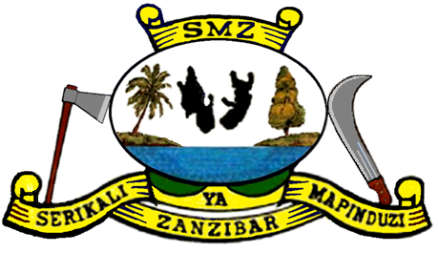
THE REVOLUTIONARY GOVERNMENT OF ZANZIBAR
MINISTRY OF FINANCE AND PLANNING (MoFP)

BOOSTING INCLUSIVE GROWTH FOR ZANZIBAR (BIG-Z)

SOLID WASTE MANAGEMENT EQUIPMENT
DEVALUATION REPORT
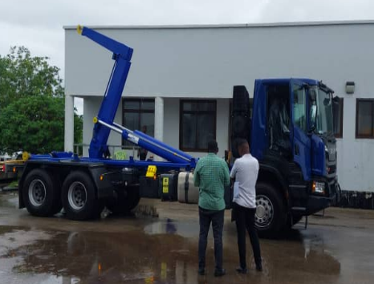 | 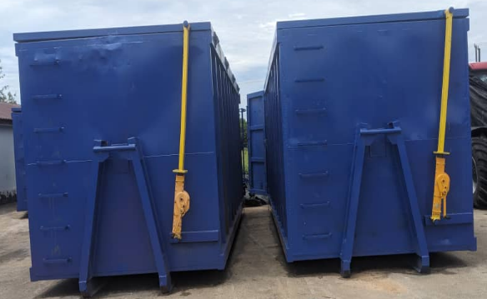 | 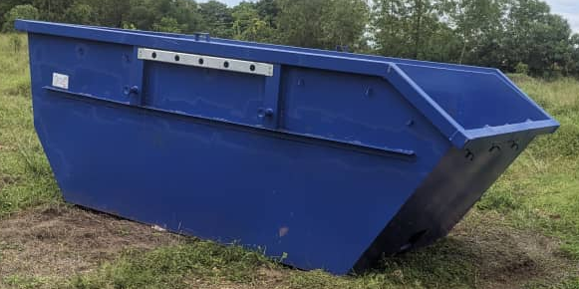

Tanzania, Project ID: P165128
IDA Credit No:69140-TZ

PREPARED BY M&E UNIT

05th DECEMBER 2025
TABLE OF CONTENTS
SECTION ONE ………………………………………………………………………………………………….3
1. Introduction 3
SECTION TWO …………………………………………………………………………………………………..4
2. Equipment Assessment 4
SECTION THREE 4
3. Key Findings 4
3.1 Equipment Receipt and Operational Status 4
3.2 Equipment Utilisation 5
3.2.1 Skip containers 5
3.2.2 Hook containers 5
3.2.3 Two (2) units of SCANIA P360 6x4 hook-lift trucks 6
SECTION FOUR 7
4. Operations, Maintenance, and Management 7
4.1 Operation 7
4.2 Maintenance 8
SECTION FIVE 9
5. Performance and Efficiency 9
SECTION SIX 10
6. Challenges Identified 10
SECTION SEVEN 10
7. Support Needs and Recommendations 10
7.1 Sustainability Measures 11
7.2 Sustainability outcomes 12
SECTION EIGHT 12
8. Conclusion 12
ANNEX 1 CONTAINER TRUCK AND EQUIPMENT LOT 3 13
ANNEX 2 SURVEY QUESTIONNAIRE 16
ANNEX 3 LIST OF PARTICIPANTS DURING SURVEY EXERCISE 17

SURVEY REPORT FOR SWM EQUIPMENT
SECTION ONE
1. Introduction
The Ministry of Finance and Planning (MoFP) is implementing the Boosting Inclusive Growth for Zanzibar (BIG-Z) Integrated Development Project, a flagship initiative financed by the World Bank with a total allocation of USD 150 million. The project, which commenced in 2021 and is scheduled to run through December 2027, seeks to promote inclusive and sustainable economic growth across Zanzibar through coordinated, multi-sector development interventions. BIG-Z focuses on improving urban infrastructure, strengthening institutional capacity, enhancing service delivery, and expanding economic opportunities for communities across Unguja and Pemba.
As part of its mandate to modernize solid waste management (SWM) services, the BIG-Z Project has procured a range of equipment aimed at strengthening municipal waste collection, transportation, and disposal systems. Specifically, the project supplied 20 skip containers (8m³), 2 hook-lift trucks, and 10 hook-lift containers (40m³) under Lot 3 and Lot 4 procurement packages. This investment is intended to enhance the operational efficiency of local government authorities, reduce environmental pollution, and support the broader transformation of municipal solid waste management systems.
To assess the current utilisation and performance of this equipment, the Monitoring & Evaluation (M&E) Unit conducted a structured field assessment using the standard BIG-Z Solid Waste Management Equipment Questionnaire. The assessment focused on evaluating utilisation levels, functionality, operational readiness, maintenance practices, and overall effectiveness of the equipment deployed in beneficiary municipalities.
This preliminary report presents key findings from the assessment and provides insights into the equipment’s operational performance, emerging challenges, and sustainability considerations. The results will support informed decision-making, guide future capacity-building initiatives, and strengthen overall asset management within participating councils.
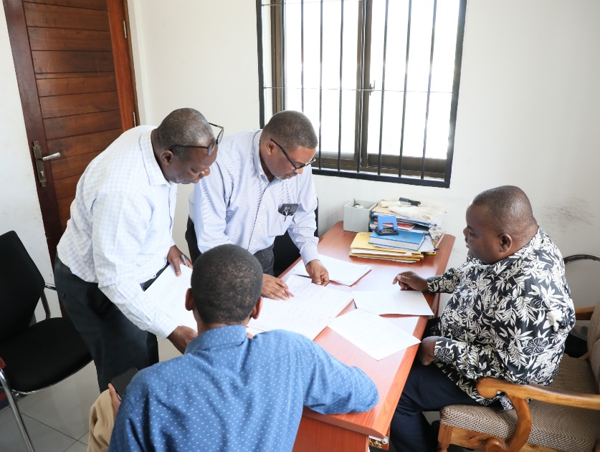 | A courtesy survey visit was paid to the Transfer Station Office, where discussions were held with Mr. Salehe Ally Abdallah, Manager of the Maruhubi Transfer Station, together with Eng. Juma Nassor Karith, Eng. Mzee Khamis Juma, and Mr. Israel Mwakilasa, Monitoring and Evaluation Specialist. The survey discussion focused on reviewing current data-capture practices, particularly the recording of the number of hook containers transferred daily and the total tonnage collected, which remains a key area of concern.

SECTION TWO:
2. Equipment Assessment
The assessment targeted a specific set of solid waste management equipment supplied under the BIG-Z Project to enhance municipal waste collection and transport capacities. The equipment reviewed included:
- Twenty (20) units of 8m³ skip containers procured under Lot 3, intended to serve as primary waste collection points in communities, construction sites, public space areas and high-volume waste-generating areas.
- Two (2) units of SCANIA P360 6x4 hook-lift trucks procured under Lot 4, designed for transporting large-capacity hook containers and facilitating efficient waste hauling operations.
- Ten (10) units of 40m³ hook-lift containers supplied under Lot 4.2, intended for bulk waste collection, long-distance hauling, and service to major urban centers.

All equipment was procured to strengthen the operational capacity of the Zanzibar Urban Municipal Council (ZUMC). The overall objective is to support improved waste handling efficiency, reduce operational delays, and enhance the quality and reliability of municipal solid waste services in line with BIG-Z’s broader environmental management goals.
SECTION THREE:
3. Key Findings
3.1 Equipment Receipt and Operational Status
The municipality confirmed that all equipment was formally handed over upon delivery, following the established procedures for commissioning and asset receipt.
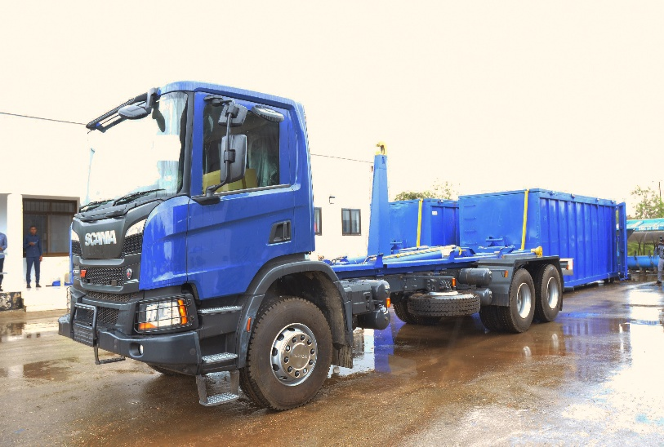 | As part of the Solid Waste Management interventions under the Big Z project, a truck and a set of containers have been successfully procured and delivered. This milestone marks an important step toward strengthening the operational capacity of municipal authorities in handling solid waste. 28.04.2025
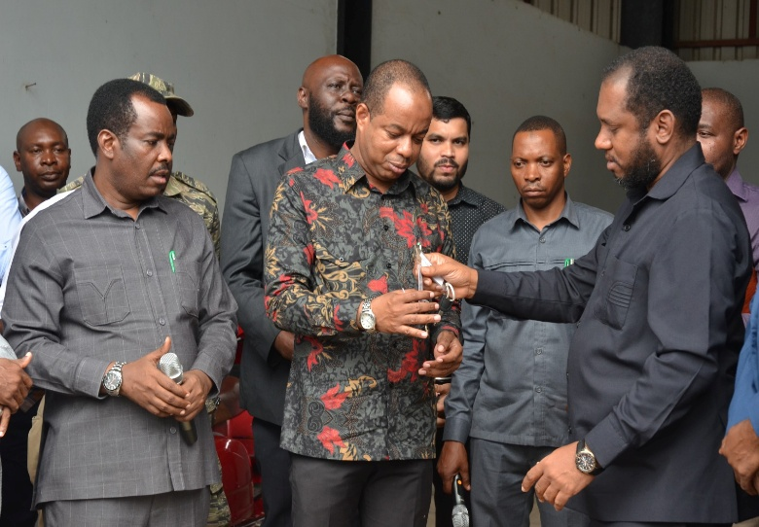 | Deputy Principal Secretary, Presidents Office, Finance and Planning Mr Aboud Hassan Mwinyi, officially handed over trucks and containers for Solid Waste Management to the Minister for the President’s Office – Regional Administration and Local Government, Mr Masoud Ally Mohamed. 28.04.2025
The majority of the skip containers are not fully deployed because they still have the old ones. Out of 20 received skip containers, 9 are actively supporting routine solid waste collection across various collection service points within the municipality. The other 11 Skip containers have been stored at Kibele landfill and are expected to be used if others are on work or if they are broken down for repair. Their utilisation has contributed to improved waste handling and operational efficiency.
The hook containers are fully deployed and are actively supporting solid waste collection at Maruhubi transfer station. Out of 10 received by municipality, only one was found lying at Kibele landfill because of defects in the handling hooks
The hook-lift trucks are reported to be in good working condition, with the municipality indicating full utilisation. Each truck currently undertakes an average of 5–6 hook-container collection trips per day, demonstrating high operational productivity and enhanced waste transport capacity.
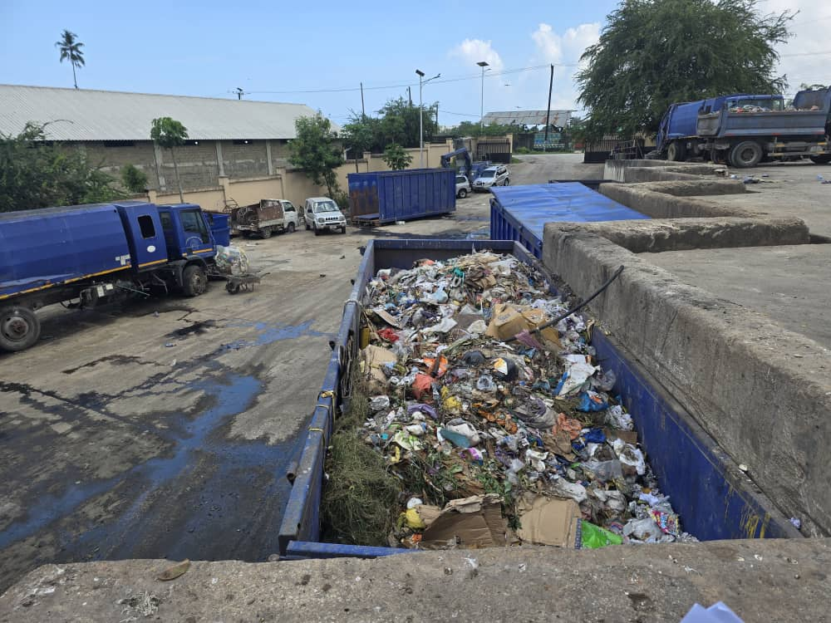 | A clear example is observed at the Maruhubi Transfer Station, where a single hook-lift truck transfers approximately five to six hook containers to the Kibele Landfill daily. Each hook container is equivalent to approximately six skip containers, demonstrating a substantial improvement in waste collection and transportation efficiency compared to the previous system, which relied solely on skip containers. This enhancement clearly evidences a significant positive change in solid waste collection operations. Appreciation is extended to the BIG-Z Project for its valuable support under the Integrated Programme.

3.2 Equipment Utilisation
Reported utilisation levels varied across the different equipment types, reflecting their distinct operational roles and the varying demands of municipal solid waste services:
3.2.1 Skip containers are widely utilized as primary community waste collection points, particularly in high-density urban areas where daily waste generation is high. They play a critical role in facilitating primary waste collection by allowing continuous accumulation of household and commercial waste and enabling short-haul transportation from neighborhood collection points. This significantly enhances accessibility, operational efficiency, and service coverage in municipal solid waste management systems.
Owing to their limited holding capacity, skip containers are primarily deployed for waste conveyance from collection points to designated transfer stations. At these transfer stations, waste is consolidated and reloaded into hook containers, which are designed for higher-capacity, long-haul transportation to final disposal sites such as the Kibele Landfill. This integrated skip-to-hook operational model optimizes logistics, reduces turnaround time, and minimizes operational costs.
The Maruhubi Transfer Station has emerged as a strategic and high-potential waste transfer hub due to the continuous availability of hook containers and hook-lift trucks stationed on-site. This arrangement enables timely loading, rapid turnaround, and uninterrupted transfer of consolidated waste to the landfill, thereby strengthening the overall efficiency and reliability of the solid waste transportation chain.
3.2.2 Hook containers are predominantly utilised for managing large-volume waste at the Mahurubi and Mpendae transfer stations. In addition, they play a critical role in transporting bulky waste to the Kibele landfill, where their high capacity enables fewer trips and improved operational efficiency.
The introduction of hook-lift containers at the Maruhubi Transfer Station has significantly enhanced solid waste operations. Currently, one hook-lift truck transfers approximately five to six hook containers daily to the Kibele Landfill, with each hook container equivalent to six skip containers. This has substantially increased collection efficiency and reduced operational constraints experienced under the previous skip-only system, underscoring the value added by the BIG-Z Project’s integrated infrastructure support.
3.2.3 Two (2) units of SCANIA P360 6x4 hook-lift trucks
The two hook-lift trucks play a critical role in strengthening solid waste collection and transportation operations within the municipalities. Their deployment has significantly reduced the accumulation of uncollected waste in urban areas, effectively easing long-standing challenges related to inadequate waste-handling equipment. The availability of these trucks has improved the efficiency, reliability, and coverage of waste collection processes, leading to visibly cleaner town environments. Overall, this intervention represents tangible and results-oriented support provided by the BIG-Z Project to government institutions in enhancing urban sanitation and service delivery.
The deployment of two hook-lift trucks under the BIG-Z Project has significantly strengthened municipal solid waste collection and transportation. Each truck supports the daily 6 transfer of hook containers to the landfill, substantially reducing waste accumulation in urban areas previously constrained by limited equipment. This intervention has improved collection efficiency, reliability, and coverage, resulting in visibly cleaner town environments. The improvement directly demonstrates the effectiveness of BIG-Z investments in enhancing municipal service delivery and urban sanitation.
This intervention directly contributes to the BIG-Z Project Development Objective of improving urban infrastructure and service delivery. The provision of hook-lift trucks has enhanced the operational capacity of municipal solid waste management services, supporting improved service efficiency, environmental sanitation, and urban livability—key outcomes under the project’s intermediate results related to solid waste management performance.
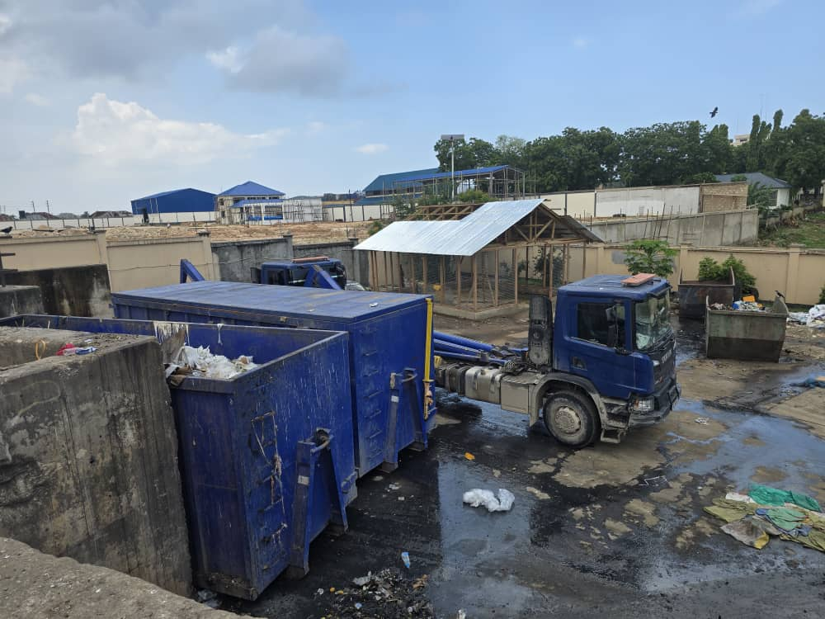
Above, The hook-lift truck stationed at the Maruhubi Transfer Station facilitates the collection and transportation of filled hook containers to the Kibele Landfill. This intervention demonstrates the significant support provided by the BIG-Z Project to the Municipality in strengthening solid waste operations and ensuring improved urban hygiene and cleanliness. | Above is one of the new hook-lift trucks provided under the BIG-Z Project for Municipality to support the collection and transportation of bulky hook containers of solid waste to the landfill.

SWM equipment is utilized daily to respond to prevailing waste generation levels and municipal collection routes, enabling multiple collection and haulage cycles per day. This operational approach has reduced waste backlogs at collection points and strengthened service continuity, contributing to improved urban cleanliness and environmental health.
Daily utilization of SWM equipment contributes directly to the BIG-Z Project Development Objective of improving urban infrastructure and service delivery. The intervention strengthens municipal capacity for regular waste collection and transportation, supporting intermediate results related to enhanced solid waste management performance and improved urban environmental conditions.
SECTION FOUR:
4. Operations, Maintenance, and Management
4.1 Operation
The equipment is operated and maintained by the municipal technical teams under the technical section of the Municipal Council, with dedicated budget allocations provided to support routine operation and maintenance. According to the Officer In-Charge of Operations, Mr. Mtumwa Farhan Mabrouk, municipal staff received comprehensive technical training from the supplier on the operation and maintenance of the trucks, including hook containers. This combination of institutional ownership, budgetary provision, and technical capacity has enabled full and sustainable operation of the equipment.
This intervention contributes directly to BIG-Z’s intermediate results related to strengthened institutional capacity for urban service delivery. The transfer of technical knowledge, combined with established municipal O&M arrangements, has enhanced the municipality’s ability to independently operate and maintain solid waste management assets in a sustainable manner.
Intermediate Result Indicator:
Enhanced operational and maintenance capacity of municipal solid waste management services.
Reported Progress:
Municipal technical staff trained on truck and hook-container O&M; equipment fully operational with dedicated
However, gaps in training remain, as not all equipment operators received formal training. This has resulted in inconsistencies in equipment handling and operational practices. In addition, the absence of comprehensive data on solid waste management—particularly waste quantities measured in tonnage and, where applicable, revenues generated from waste collection services across different waste producers—limits effective performance monitoring, cost recovery analysis, and evidence-based decision-making. Addressing these gaps through structured training programs and strengthened data management systems will be essential for improving operational efficiency, financial sustainability, and accountability within the solid waste management system.
4.2 Maintenance
Preventive maintenance practices remain insufficient, with municipal council relying predominantly on reactive maintenance undertaken after equipment breakdowns rather than on structured preventive maintenance schedules. Furthermore, the availability of critical spare parts is inconsistent, as procurement often depends on mainland suppliers, resulting in delays, extended equipment downtime, and increased operational costs.
These gaps pose risks to the sustainability of solid waste management operations by increasing the likelihood of service interruptions, accelerating equipment wear and tear, and raising lifecycle maintenance costs. Prolonged downtime may also undermine service reliability, negatively affecting urban sanitation outcomes and public confidence in municipal service delivery.
During the site visit, it was observed that the concrete loading and off-loading bay at the Maruhubi Waste Transfer Station has been damaged for some time. The Transfer Station Manager noted that failure to repair the damaged bay poses a risk of damage to the rollers of the hook-lift containers during loading and off-loading operations. The Manager further indicated that similar damage had previously occurred due to the poor condition of the loading surface, serving as a key lesson learned.
Rehabilitation of the damaged loading area would help prevent further wear and damage to the hook-container rollers during operations. Mitigating this identified risk is necessary to ensure sustainable service delivery and to enhance the durability and operational lifespan of the hook-lift containers.

To mitigate these risks, the following measures are recommended:
- Establish and enforce preventive maintenance schedules for all SWM equipment at the municipal level.
- Strengthen technical capacity through refresher training on equipment operation and routine maintenance.
- Develop a standardized inventory management system and framework contracts for commonly used spare parts to reduce procurement delays.
- Allocate and ring-fence annual budget provisions specifically for preventive maintenance and spare parts.
SECTION FIVE
5. Performance and Efficiency
Respondents reported notable improvements in municipal solid waste management following the deployment of SWM equipment under the project:
- Increased waste collection efficiency:
The introduction of modern equipment, including hook-lift trucks and containers, has substantially improved the volume and frequency of waste collected. Municipal teams are now able to conduct multiple collection and haulage cycles per day, reducing backlogs at collection points and improving operational coverage.
- Reduced turnaround time at disposal sites:
Improved transportation capacity has shortened turnaround times between collection points, transfer stations, and the landfill. This has enhanced fleet utilization, minimized idle time, and enabled faster clearance of collected waste.
- Improved service delivery and urban cleanliness:
Regular and more reliable waste collection has contributed to visibly cleaner environments in targeted urban areas. Reduced waste accumulation has improved public hygiene conditions and strengthened community confidence in municipal service delivery.
- Enhanced capacity to manage bulky and industrial waste:
The availability of hook containers and specialized trucks has improved the municipalities’ ability to handle bulky, high-volume, and industrial waste streams that were previously difficult to manage under the traditional skip-container system.
However, performance is affected by:
Limited operator competence:
Not all operators have received formal or refresher training, resulting in uneven equipment handling practices and suboptimal utilization of the available assets.

SECTION SIX:
6. Challenges Identified
Respondents consistently highlighted several challenges affecting the effective and sustainable operation of solid waste management equipment:
- Frequent technical breakdowns and prolonged repair timelines:
Equipment downtime remains a significant challenge due to mechanical failures and a predominantly reactive maintenance approach. Lengthy repair timelines—often linked to limited spare-parts availability and delayed procurement processes—reduce equipment availability and disrupt scheduled waste collection services.
- Insufficient trained personnel for hook-lift systems:
A shortage of adequately trained operators for hook-lift trucks and containers was widely reported. While initial training was provided, gaps persist due to staff turnover and limited refresher training, resulting in inconsistent operation practices and increased risk of equipment damage.
- Limited local availability of spare parts:
Critical spare parts are not readily available locally and often must be sourced from mainland suppliers. This dependency leads to delays in maintenance and repairs, extended equipment downtime, and higher operational costs.
- Budgetary constraints for routine operation and maintenance:
Insufficient or irregular budget allocations for fuel, preventive maintenance, spare parts, and minor repairs constrain the full and continuous utilization of the equipment. These limitations become more pronounced during periods of high waste generation.
- Weak internal management and asset control systems:
Inadequate internal systems for scheduling, supervision, and asset tracking limit effective fleet management. The absence of structured maintenance schedules, performance monitoring tools, and asset registers undermines accountability, planning, and timely decision-making.
Collectively, these challenges pose risks to the sustainability and efficiency of municipal solid waste management services. Addressing them through targeted capacity building, strengthened operation and maintenance systems, improved budget planning, and enhanced asset management will be critical to safeguarding the long-term impact of BIG-Z investments in urban sanitation and service delivery.
SECTION SEVEN
7. Support Needs and Recommendations
Based on consultations and operational experience with the solid waste management (SWM) intervention, respondents proposed the following measures to improve equipment utilization, performance, and sustainability:
- Strengthen technical capacity through targeted training:
Implement structured and continuous technical training programs for equipment operators, mechanics, and municipal managers. Training should cover operation, preventive maintenance, safety procedures, and basic troubleshooting for hook-lift trucks and containers, with refresher courses included to address staff turnover.
- Establish maintenance contracts with qualified service providers:
Develop and enforce maintenance service contracts with reliable suppliers to support routine preventive maintenance and timely corrective repairs. Such contracts would help reduce equipment downtime, improve response times, and extend the operational lifespan of SWM assets.
- Improve spare parts availability and supply chain reliability:
Strengthen the spare-parts supply chain by pre-identifying critical components, establishing framework agreements with suppliers, and maintaining minimum stock levels at the municipal level. This approach would reduce dependence on ad hoc procurement and minimize service disruptions caused by delayed repairs.
- Allocate ring-fenced operation and maintenance budgets:
Ensure dedicated and adequately funded operation and maintenance (O&M) budgets are allocated within municipal annual plans. Ring-fencing resources for fuel, routine servicing, spare parts, and minor repairs is essential to sustain uninterrupted waste collection, particularly during peak periods.
- Enhance policy, institutional, and management frameworks:
Strengthen internal policy and management systems governing SWM equipment utilization, including clear operational guidelines, asset management registers, maintenance schedules, and performance monitoring tools. Improved governance frameworks will support accountability, planning, and data-driven decision-making.

Implementation of these recommended interventions will enhance the operational efficiency, reliability, and sustainability of municipal solid waste management services. The measures directly support the BIG-Z Project Development Objective of strengthening urban infrastructure and institutional capacity for service delivery, while contributing to intermediate results related to improved solid waste management performance and environmental sanitation outcomes.
7.1 Sustainability Measures
To safeguard the long-term effectiveness of the solid waste management intervention and maximize the return on investment in SWM equipment, the following sustainability measures are recommended:
• Development of municipal-level sustainability plans:
Municipalities may consider preparing and adopting tailored solid waste management (SWM) sustainability plans that outline long-term operational, financial, and institutional arrangements for equipment management. Such plans would help guide approaches to cost recovery, asset lifecycle management, staffing, and ongoing capacity development, supporting continuity of service delivery beyond the project period.
• Integration of structured preventive maintenance schedules:
There is an opportunity to further strengthen preventive maintenance practices by integrating structured maintenance schedules for all SWM equipment, including hook-lift trucks, containers, and support vehicles. Embedding regular maintenance planning within existing municipal systems, supported by maintenance records and appropriate budgetary provisions, would support reduced equipment downtime and extended asset lifespan.
• Strengthening institutional coordination and oversight:
Enhanced coordination among the Project Management Team (PMT), PORALGSD, ZUMC, and other municipal councils could further promote consistent policy implementation, effective technical oversight, and comprehensive performance monitoring. Clearer role delineation and communication channels would support informed decision-making and timely resolution of operational matters.
• **Establishment and application of Standard Operating Procedures (SOPs):
The development and gradual rollout of standardized operating procedures for solid waste equipment management—including operation, maintenance, safety, reporting, and asset tracking—could contribute to more uniform practices across municipalities. Accompanied by training and routine supervision, SOPs would strengthen accountability, operational efficiency, and overall service quality.
7.2 Sustainability outcomes
These sustainability measures reinforce the BIG-Z Project Development Objective of strengthening institutional capacity and improving urban service delivery. By embedding preventive maintenance, coordinated oversight, and standardized operational systems at the municipal level, the SWM intervention is positioned to deliver sustained improvements in environmental sanitation and municipal service performance..
SECTION EIGHT:
8. Conclusion
The assessment confirms that the solid waste management equipment supplied under the BIG-Z Project is largely functional and has made a measurable contribution to strengthening municipal waste collection, transportation, and service delivery. The deployment of the equipment has improved operational efficiency, reduced waste accumulation in urban areas, and enhanced overall sanitation outcomes in targeted municipalities.
Notwithstanding these gains, the assessment notes some technical, operational, and financial aspects that require further strengthening to enhance optimal equipment utilisation. These include the need for expanded operator capacity, more structured preventive maintenance practices, improved availability of spare parts, and more consistent arrangements for operation and maintenance financing..
Continued attention to capacity building, enhancement of maintenance and asset management systems, and the strengthening of sustainable municipal financing arrangements will support the sustained functionality of the equipment, optimise its lifecycle performance, and contribute to the long-term realisation of the BIG-Z Project’s urban sanitation and institutional development objectives.

ANNEX 1.
CONTAINER TRUCK AND EQUIPMENT LOT 3
SKIP CONTAINER 8 m3 QUANTITY 20 UNITS
Supply and delivery of a commercially available Skip Container 8 m³. To fit and conform to the Skip Container truck in operation by ZUMC (Scania P 240)
Lot No; 4 Hook lift Trucks 4X4: 2 Units
Condition
- Hook lift Trucks
- Make: SCANIA P360B6X4HZ
- Chassis No YS2P6X40005751776 and YS2P6X40005750349
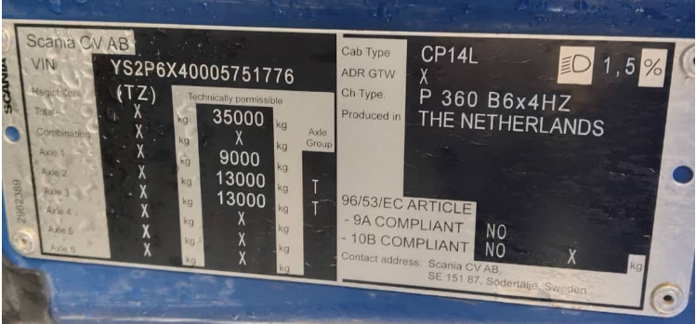 | 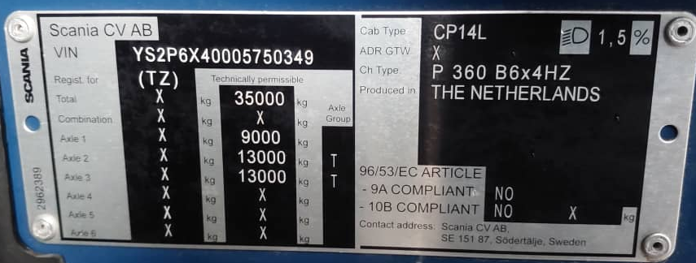
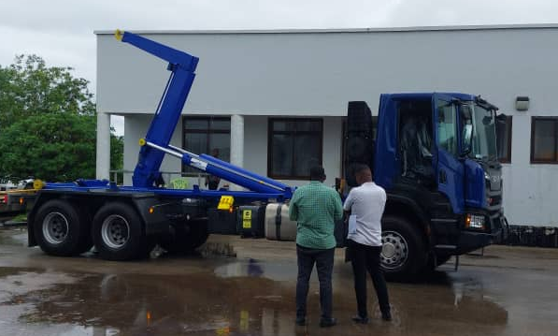 | 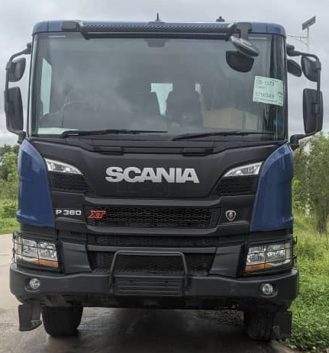

CONTAINER TRUCK AND EQUIPMENT
LOT 4.2: HOOK CONTAINER 40 m³ QUANTITY: 10 UNITS
Supply and delivery of commercially available hook lift container40 M³m³. To fit and conform to the Hook Lift Container truck (Lot 4.2)
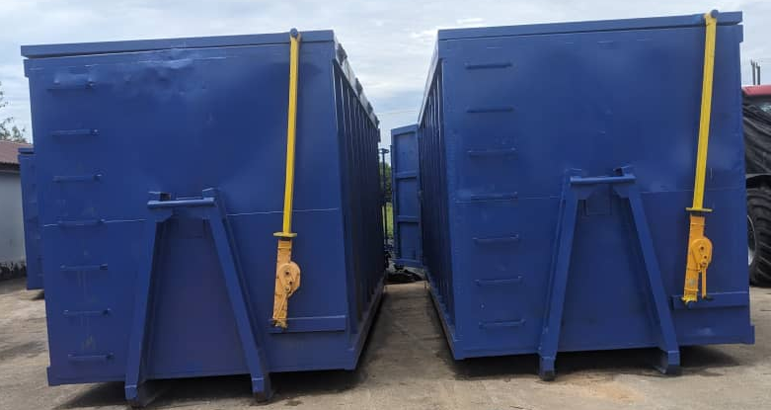
DEFINITIONS
Skip Containers (Skip Bins)
These are open-topped waste containers that are commonly loaded onto a skip loader truck.
Key features:
- Usually smaller in size (common sizes: 4m³, 6m³, 8m³, 10m³).
- Designed for construction waste, household waste, renovation debris, etc.
- Lifted onto the truck using chains attached to lifting lugs.
- Typically used for temporary waste collection at a site.
How they are loaded:
- The truck brings the skip bin, places it on-site.
- When full, the truck returns, lifts the container using the chain system, and transports it to a disposal site.
Hook Containers (Hook-Lift Containers / Roll-On Roll-Off Bins)
These are larger waste containers that are loaded on a truck using a hook-lift arm.
Key features:
- Larger capacity than skip containers (15m³ to 40m³).
- Used for bulky waste, industrial waste, large construction projects.
- Loaded and unloaded by a hydraulic hook arm pulling the container onto the truck.
- Allows quick loading, as the container slides on and off the truck chassis.
How they are loaded:
- The truck reverses to the container.
- A hydraulic hook arm grabs the bin and pulls (rolls) it onto the truck bed.
Summary of Differences
Feature | Skip Container | Hook Container (Hook-Lift)
Loading mechanism | Lifted by chains | Pulled by hydraulic hook arm
Size | Small to medium (4–10 m³) | Large (15–40 m³)
Common use | Household waste, small sites | Industrial waste, big construction
Truck compatibility | Skip loader truck | Hook-lift truck (roll-on roll-off
Flexibility | Less versatile | Highly versatile and fast to load

ANNEX 2 SURVEY QUESTIONNAIRE
BIG-Z Project – Equipment Utilisation Assessment Survey
Implementing Agency: Project Management Team (PMT)
Component: Solid Waste Management
Administered by: Monitoring & Evaluation Unit (M&E)
Purpose: To assess the utilisation, functionality, and management of equipment procured under the BIG-Z Project and identify operational challenges, capacity needs, and sustainability measures.

Section A: General Information
- Name of Respondent: ___________________________
- Designation/Position: ___________________________
- Department/Institution: Municipal Council ☐
- Region/Municipality: ___________________________
- Date of Assessment: ___ / ___ / 2025

Section B: Equipment Details and Operational Status
- List of equipment available at your unit procured by the Big Z project:
☐ Hook trucks ( Number of Hook Trucks …………..received )
☐ Skip containers (Number of Skip Containers ………..Received)
☐ Hook Containers ( Number of Hook Containers ……….Received)
When was the equipment received? ___________________
- Was the equipment formally handed over and commissioned for use?
☐ Yes ☐ No (If no, explain) ________________________
- Is the equipment currently in use?
☐ Fully operational ☐ Partially operational ☐ Not operational
- If partially or not operational, specify reasons:
☐ Technical breakdown
☐ Lack of trained operators
☐ Lack of spare parts or fuel
☐ Awaiting allocation/transfer
☐ Other (specify) ______________________
- On average, how frequently is the equipment used?
☐ Daily ☐ Weekly ☐ Occasionally ☐ Rarely
- Rate the overall utilisation of the equipment (1 = Very Low; 5 = Very High):
☐ 1 ☐ 2 ☐ 3 ☐ 4 ☐ 5

Section C: Operation, Maintenance and Management
- Who is responsible for operating the equipment?
☐ Municipal technical team ☐ Hired operators ☐ Private contractor ☐ Other ___________
- Have the operators received any formal training?
☐ Yes ☐ No (If yes, specify type/date) __________________
- Is there a scheduled maintenance plan in place?
☐ Yes ☐ No
- How frequently is preventive maintenance conducted?
☐ Weekly ☐ Monthly ☐ Quarterly ☐ When breakdown occurs only
- Are spare parts and consumables readily available locally?
☐ Always ☐ Sometimes ☐ Rarely ☐ Never
- Is there a designated budget for maintenance and operations?
☐ Yes ☐ No ☐ Not sure

Section D: Performance and Efficiency
- How would you rate the performance of the equipment in achieving its intended purpose?
☐ Excellent ☐ Good ☐ Average ☐ Poor ☐ Not sure
- What improvements have been observed since the equipment was deployed?
☐ Improved waste collection efficiency
☐ Improved the quality standard
☐ Improved cleanliness/service delivery
☐ Increased staff productivity
☐ Other (specify) __________________
- Provide quantitative performance data if available (e.g., number of trips per day, hours of broadcast per week, etc.):
Section E: Challenges and Support Needs
- What key challenges do you face in using or maintaining the equipment?

- What type of support or intervention would enhance utilisation?
☐ Technical training
☐ Maintenance contracts
☐ Spare parts supply chain
☐ Budget allocation
☐ Policy/management support
☐ Other (specify) __________________
- Any lessons learned or best practices worth sharing?

Section F: Sustainability and Institutional Readiness
- Does your institution have a sustainability plan for the equipment?
☐ Yes ☐ No ☐ Under preparation
- Are there measures in place to ensure continued functionality after project closure?
☐ Yes ☐ No (If yes, specify) ______________________
- Suggestions for strengthening sustainability:

Section G: Overall Feedback
Please provide general remarks or recommendations on improving the equipment’s utilisation and management:

ANNEX 3 LIST OF PARTICIPANTS DURING SURVEY EXERCISE
Sno | Name | Designation | Institution | Mobile
1. | Mr Israel A. Mwakilasa | M&E Specialist | BIG-Z | 0754801079
2. | Eng Mzee K.Juma | SWM Specialist | BIG- Z | 0777413043
3. | Mr Hamid A. Haji | M&E officer | BIG-Z MoFP | 0772363637
4. | Ms Mwanajuma M. Ameir | M&E officer | BIG -Z MOIT | 0777664545
5. | Eng Juma Nassor Kharith | Municipal Engineer | Municipal | 0777867288
6. | Mr Suleiman Abdulla | Communication officer | BIG Z MoFP | 0712930766
7. | Mr Mtumwa Farhan | Transport officer | Municipal | 0777867288
8 | Mr Salehe Ally Abdallah | Transfer Station Manager | Maruhubi Station | 0777471176
9. | Abdi Abdallah Ali | Landfill Manager | Kibele Landfill | 0777462208

